To apply for an internal COA grant using Infoready, please follow the link provided on the opportunity information page. It will take you to the Infoready opportunity, which should appear as below. You may download needed templates from this page. When ready, select “Apply” on the right-hand side of the screen.
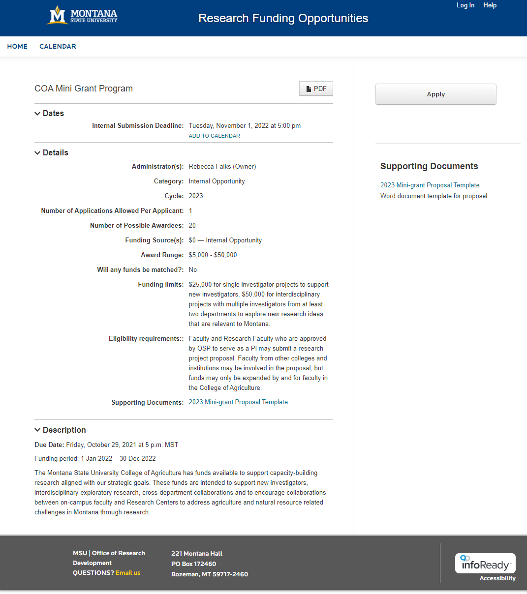

Login to Infoready using your MSU Single Sign On.

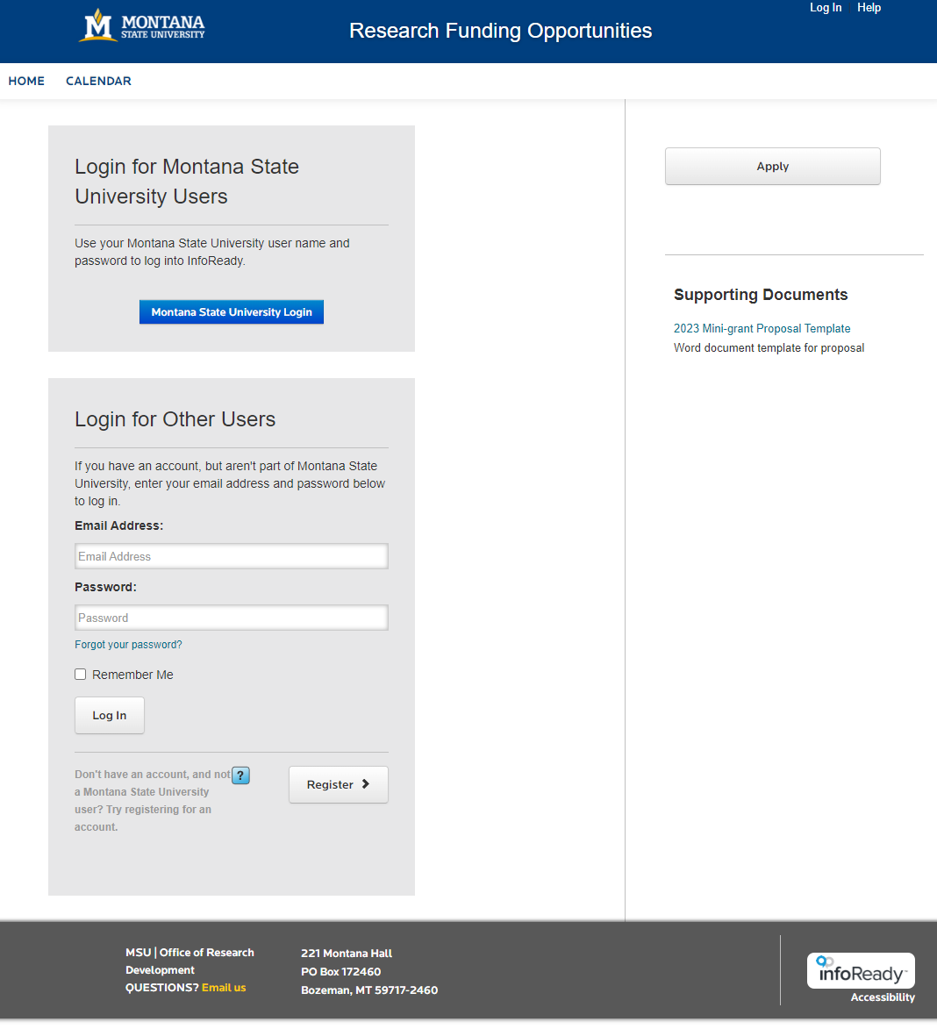

Fill in the needed information for yourself and any Co-PIs, and upload your proposal as a pdf. When ready, submit the application. You will be automatically notified when your application is received.

